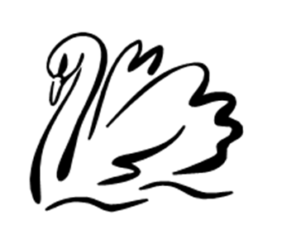
You are hereby summoned to attend the next ordinary meeting of Gillingham Parish Council to be held on Tuesday 3rd March 2026 at 6.30pm in the Gillingham Village Hall.

Press and public are welcome to attend and there will be an opportunity for public participation at agenda item No 4

- Welcome

- Apologies for any absences and recorded numbers of public

- Minutes – to confirm the minutes of meeting held on 3rd February 2026 as a true and correct record.

- Parish Ten

- Outstanding Matters

- Litter Picking Event – Big South Norfolk Litter Pick 2026 – 19th Feb – 31st May 2026.
- Armed Forces Day – 27th June 2026 – Had a letter from the House of Commons to support communities in marking the occasion, I am delighted to announce that the Government has made £500,000 worth of grants available nationally for local Armed Forces Day events, with grants of up to £10,000 available for each event.
- Tree – Have these been planted yet? – Will need photos to send to the Plant to Bloom to show them what the money was spent on.

- Planning

- Gillingham Services Station – up date?

- Parish Council Matters

- Parish Council Training for New Members
- AGM – this will take place at our April meeting- by then all the bank rec will have been sorted.

- Finance

- Clerk Wages
- Tops Garden
- PKF - Invoice SB20243410

- Correspondance

- NNDC – Emailing regarding New bin on Forge Drive
- ALC – regarding parish council training.

