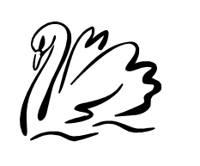
You are hereby summoned to attend the next ordinary meeting of Gillingham Parish Council to be held on Tuesday 3rd February 2026 at 6.30pm in the Gillingham Village Hall.

Press and public are welcome to attend and there will be an opportunity for public participation at agenda item no:4

- Welcome

- Apologies for any absences and recorded numbers of public

- Minutes - to confirm the minutes of meeting held on 2nd December 2025 as a true and correct record.

- Parish Ten

- Outstanding Matters

- Litter Picking Event – this needs to be rearranged
- Lighting at the Gillingham Turning

- Planning
- Change of use of traditional farm buildings to form residential dwelling linked to 2023-0682

- Finance
SNC Dog Bins - £834.00
Norfolk Association of Local Councils - £211.00
D. Baker £300.00 – Trees
Norfolk Association of Local Councils - £84.00 Website Hosting Fee
D Bracey – Annual Play inspection at Kings Dam £120.00
Clerk Wage/ Expenses

- Correspondance
- Highways – regarding Lighting on Turning into Gillingham – haven’t heard back need to chase

