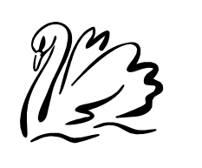
Gillingham Parish Council Meeting
Tuesday 1st April 2025
At the Gillingham Village Hall at 6.30pm

Agenda

All members of the council are hereby summoned to attend. Members of the press and public are welcome to attend and there will be an opportunity for public participation at agenda item no 4.

- Welcome

- Apologies for absence received and record number of public members

- To approve the minutes from 4th March 2025

- Parish Ten – Public Forum

- Outstanding Village Matters

- Mole Hills –Some Solar powered alarms have been ordered and will be put in place once arrived. Hopefully this will help with our mole problem in the playground area.

- Litter Picking Event 12th April.

- Cyclist Lane on Gillingham Dam

- Playground Tidy Up

- Dog Bin

- Finance

- Chq For Clerk Wages and Expenses.
- Chq For South Norfolk Council – Plant in Bloom - £300.00 – this had to be returned as money was not spent in the time frame we were given.

- Parish Council Matters

- New Council Members
- Tiding Update
- Banking – New Mandate

- Correspondence
- Email to Highways regarding Cyclist Lane
- Email to SNDC regarding our littler picking event.

